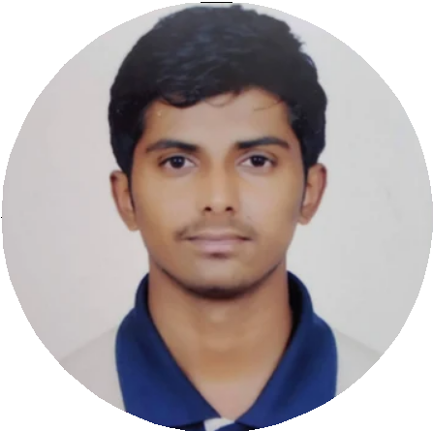Shreeyash Pednekar

Computer Engineering Undergraduate

**Education**

## Pimpri Chinchwad College of Engineering and Research

COMPUTER ENGINEERING

* CGPA : 9.21/10

## Amrita Vidyalayam Jr. College

HSC SCIENCE

* Percentage: 71.54

## Amrita Vidyalayam

SSC

* Percentage: 89.2

Ravet,Pune

*June 2018 - May 2022*

Nigdi, Pune

*June 2016 - May 2018*

Nigdi, Pune

*June 2006- May 2016*

**Skills**

## Languages Database

**Other technologies**

C++ , Python, Java MySQL, SQL Server HTML, CSS, JavaScript

# Experience

**FIS GLOBAL (Full - time)** Bangalore,India

**IT TRAINEE** *Jun 2022 -* Ongoing

**Corporate Data Lake**

**CDA Data Governance Team**

Worked on tasks like:

STM Review, Axon Onboarding,

Service Now Tickets, Defining

Data Quality Rules, SSMS.

Tech Stacks Used : Axon, SQL,

Informatica Data Quality.

## Verzeo Edutech

WEB DEVELOPMENT INTERN

* Worked on the Web App called Sleep Hours Tracker
* Tech stack used: HTML, CSS, JavaScript, Bootstrap, Nodejs , MySQL.

Pune, India

*Apr 2021 - May 2021*

# Academic Projects

## Second Hand Book Selling App

Skills used : Android Studio, Firebase, Java

## Sleep Hours Tracker

Skills used : HTML, CSS, Bootstrap, Nodejs, MySQL

# Extracurricular Activity

Member of PCCOE&R Promethean Club Member of PCCOER Art Circle

Attended various workshops like Drone, Git hub, Cyber Security and Ethical Hacking Helped in managing few events for Junior class students.

**Certifications**

Getting Started with Python (Coursera) Python Data Structures (Coursera) HTML Workshop (Geeks For Geeks)

**Contact Details**

Email - [shreepednekar01@gmail.com](mailto:shreepednekar01@gmail.com) LinkedIn - Shreeyash-Pednekar Mobile- (+91) 8446539730